AOS-CX Configuration API Support For Central Gateway

**Labels: ArubaOS-CX Switches, Aruba Central**

**Q:**

Do we have support for AOS-CX configuration API in Central Gateway ?

AOS-CX configuration gateway API that we are talking about is shown on the left side of below image.

[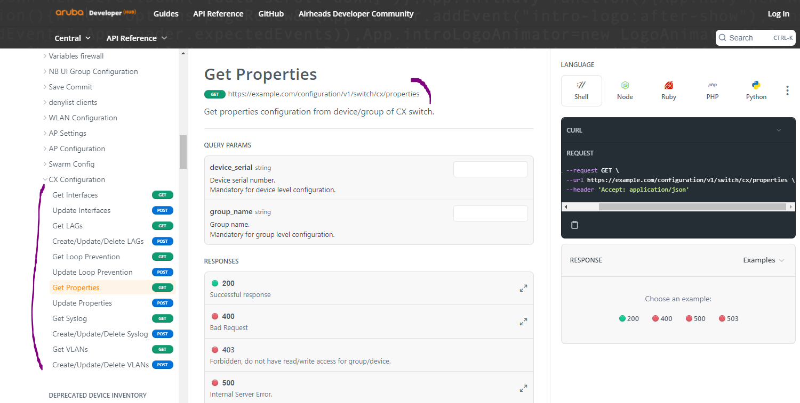](https://akb.arubanetworks.com/media/ckuploads/1110/2022/04/30/aruba-central-configuration-cx-configuration.PNG)

API gateway in Central refers to below, it can be different for your license.

[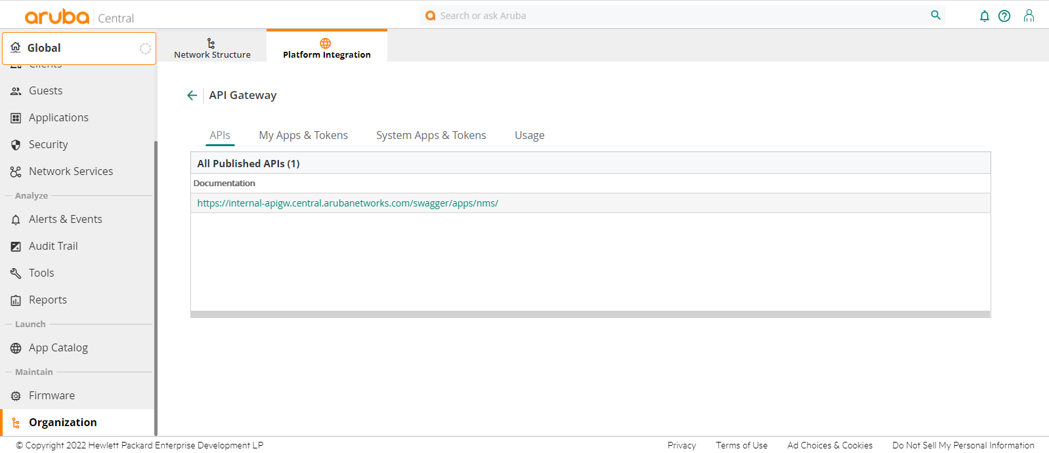](https://akb.arubanetworks.com/media/ckuploads/1110/2022/04/30/api-gateway-wheretogo.PNG)

**A:**

**As of now AOS-CX config API as seen in Developer Hub is not yet supported in Central gateway.**

Here is a GET call using Postman to the Central Gateway using Developer Hub's CX configuration method (configuration/v1/switch/properties).

And the 400 BAD REQUEST message.

[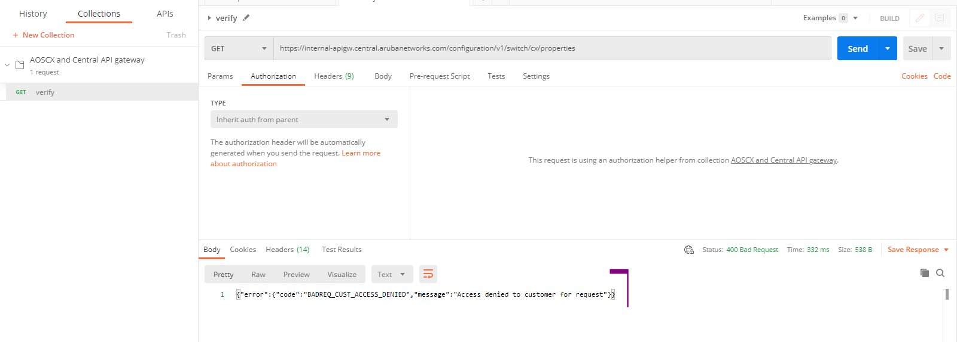](https://akb.arubanetworks.com/media/ckuploads/1110/2022/04/30/bad-request.PNG)

Tags: ArubaOS-CX Switches, Aruba Central, arubaos-cx 10.08.xxxx, #aos-cx, #aruba central, #api, developer hub